**WeatherPy Report**

***Kaveh Amini***

The objective of this project was to analyze the weather data from over 500 cities selected randomly to investigate the correlation between the latitude and the weather conditions.

As it can be clearly observed in Fig. 1 there is a correlation between latitude and temperature. The closer we get to the equator (latitude = 0), the higher the temperature is.

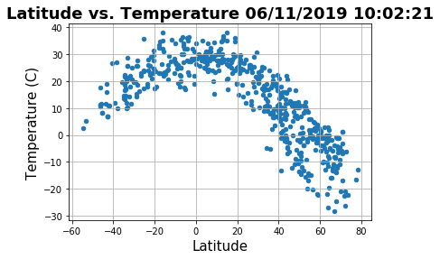

Fig. 1 Dependence of Temperature on Latitude

With regards to the correlation between latitude and humidity, according to Fig. 2 we can say that there is only a week correlation. For cities located between latitude 60 and 80 the humidity is over 40%.

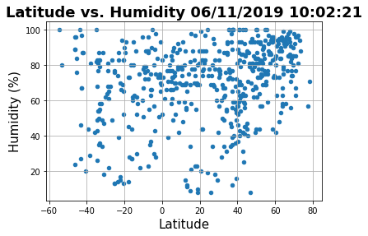

Fig. 2 Dependence of Humidity on Latitude

In the case of cloudiness, no correlation is observed between latitude and

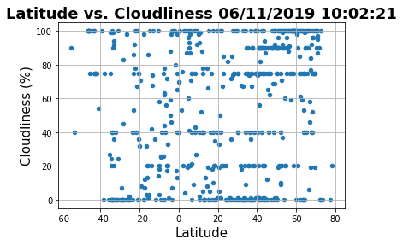cloudiness (Fig. 3).

Fig. 3 Dependence of Cloudiness on Latitude

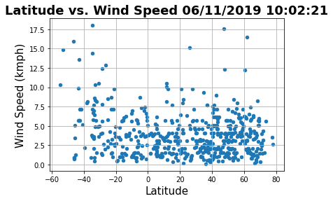For wind speed also a very week correlation can be observed (Fig. 4)

Fig. 3 Dependence of Wind Speed on Latitude